Equality and Diversity Annual Report 2020/21

Introduction

The University of Suffolk aims to realise a diverse scholarly community dedicated to people and ideas, where we work together as educators, researchers, professional services, technical staff and students. The University remains committed to advancing and promoting equality and recognises the value that diversity brings to an environment such as ours. Inclusivity is a fundamental part of ‘who we are’ at the University of Suffolk. We recognise that a diversity of backgrounds is a key part of our community and will therefore positively influence our successes as a community education provider. We very much wish to see a continued broadening in the diversity of our People – both staff and students - and we remain committed to providing an environment where everyone is supported to flourish and fulfil their potential, irrespective of their background.
In respect of our staffing base, we aspire to at least represent our local community in the diversity profile of our staff. In respect of our students, we welcome the richness that a diverse student population brings, and we feel that diversity adds vibrancy to our university; this is something that we would not want to lose and that we hope to continue to grow.
As a university we remain committed to the journey we have started, as underpinned by our vision and values. Authentic inclusivity requires sustained attention and action across all areas of potential discrimination and inequality. We continue our journey to be a more diverse employer and educator. We know that we still have work to do in this respect. This report highlights our current Equality, Diversity and Inclusion (EDI) metrics and developments – at the close of the 2020-21 academic year and outlines our aims and priorities for the coming year.

Professor Mohammad Dastbaz Julie Burton
Deputy Vice-Chancellor and Director of People and Organisational Development
Chair of the EDI Committee and Deputy Chair of the EDI Committee

Key achievements – 2020-21

At the start of the 2020-21 academic year, the following priority areas were identified for development throughout the year. Progress made is noted against each priority area:

2020/21 Priority | Progress made
Vice Chancellor ‘focus topic’ for the year (EDI) which aimed to refresh the university’s EDI approach, including the EDI Committee, Terms of Reference and a desire to make engagement more action orientated | EDI Committee saw a full refresh of membership, Terms of Reference and priority areas. Priority workstreams sitting underneath the committee comprise:  - Access and Participation Planning  - Athena Swan  - People  - Liberating the Curriculum
Offering a programme of development activities / learning on EDI topics throughout the year to raise the profile of EDI in the university | Equality and Diversity training required to be completed by all new starters and refresher training to be undertaken every 3 years – mandatory training  Unconscious bias / EDI Essentials training offered as part of Corporate Development programme and EDI training delivered to our Board.  Active Bystander training offered as part of Corporate Development programme  Recruitment & Selection of Students and Staff training covers EDI.
Staff Networks and informal support groups were to be put back in the hands of the groups of people that they were created to represent – empowering ownership of EDI matters and moving away from a ‘People and OD Directorate-led’ approach | Staff Networks and informal staff support groups further developed by those that they have been set up to represent:  - Anti-racism collective  - Disability (currently without a Chair / inactive)  - Family Carers (currently without a Chair / inactive)  - LGBTQI+  - Menopause

Other notable achievements in addition to those listed above include:

  - A series of talks/lectures were organised by the LGBTQI+ network on ‘Queering the Curriculum’, which were well attended and reviewed
  - Continuation of Suffolk Mind Wellbeing Audits – to understand better our staff’s wellbeing needs
  - Further development of our whole university Wellbeing toolkit – which is available to all on our intranet
  - Continued use of SilverCloud - an online portal providing space resources for thinking and feeling better about common issues affecting mental health
  - The development of dedicated polices on Domestic Abuse and Trans Equality due to be published in 2021/22.

Our data and metrics: Institutional profile (2020-21)

All data relating to students includes both Ipswich campus students and those who are enrolled with our partner organisations, and for whom University of Suffolk is their course awarding institution. University of Suffolk does not hold any responsibility (and therefore data) in relation to the staff of our partner organisations, and these individuals do not form part of this report. Student data is taken from the internal Student Record System. Staffing data is taken from our HR Information System.

By gender
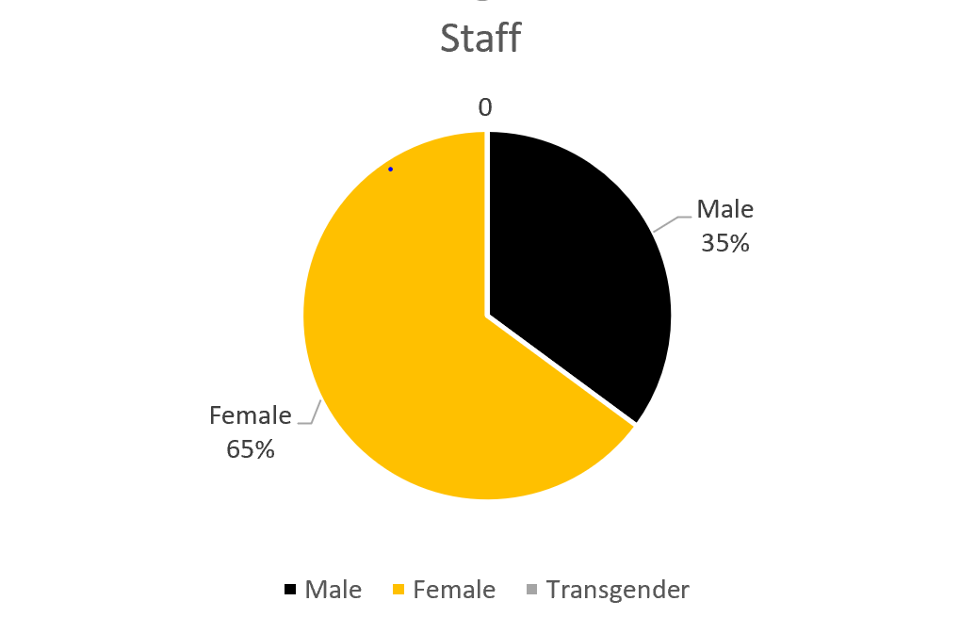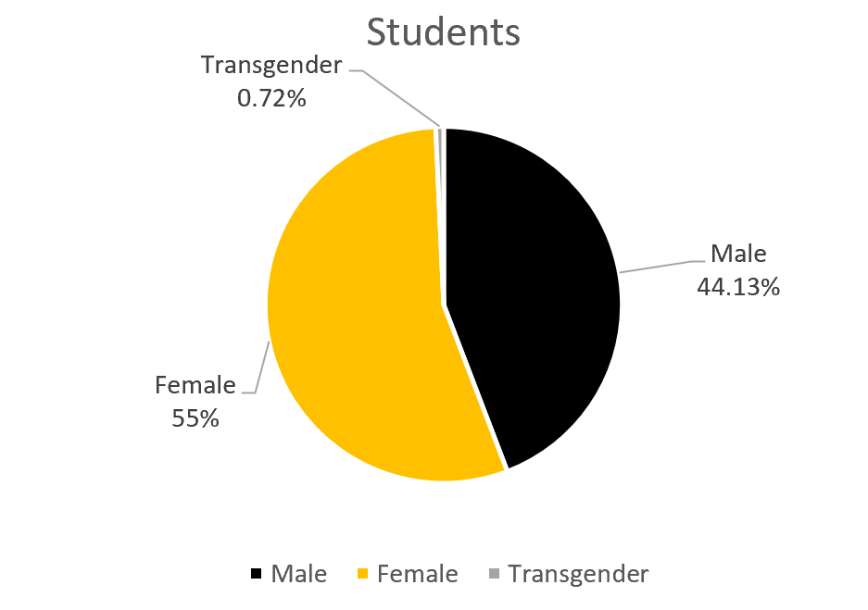
Figure 1: Staff and Student gender balance 2020-21

Our staffing profile gender split remains consistent with previous years – sitting at 65% female to 35% male. No staff have reported as identifying as transgender.
We have seen an encouraging shift in the gender profile of our students with an increase of 15.13% in male students (to 44.13%) and 0.72% identifying as transgender.

We continue to advertise our employment opportunities openly to attract a wide and balanced field of applicants but struggle to attract male candidates into lower graded professional services roles. We intend to continue to work with local partners, such as the Job Centre to understand the local job market dynamics and if we can take any actions to attract more men into our vacant roles.

We still do not have any members of staff that identify and declare themselves as transgender. Whilst we are aware anecdotally that some staff and students identify as non-binary, our formal reporting systems do not hold this information. This is an area that we shall look to develop with the pending upgrade of our HR information system and of course it is crucial that individuals feel comfortable to declare such information. It is important that our recruitment processes encourage all individuals to apply to work at the University of Suffolk, and so further consideration will be given to how we may have more success in attracting non-cis gendered applicants to our vacancies.

The Gender Pay Gap refers to the percentage by which the average pay for female members of staff is lower than the average pay for male members of staff. The University’s Gender Pay Gap is shown in Figure 2.

 | Mean(average) | Median (middle)
2020/21 | 15.9% | 17.7%
2019/20 | 13.3% | 15.1%
2018/19 | 15.3% | 18.7%
2017/18 | 14.9% | 18.9%
2016/17 | 14.6% | 14.1%
Figure 2. Gender Pay Gap as of 31st March each year.

It is disappointing to see the improvements seen last year in our gender pay gap being lost during 2020-21. Whilst we remain confident that women are able to progress within and across the University, there are some influencing factors which have altered our pay gap position this year - most notably the uneven distribution of genders across the grading structure, including the underrepresentation of men at the lower and lower-middle quartile.

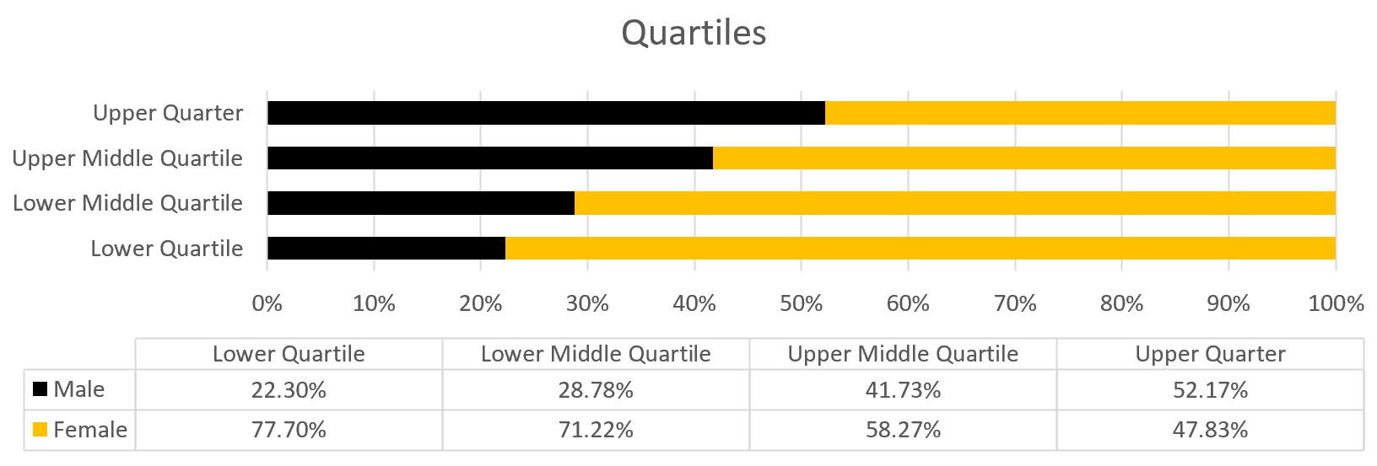
Figure 3. Gender by quartile 2020-21

By trans status

As stated above, the University does not currently have any members of staff who have disclosed that they are transgender. We are pleased to see that within our student population we have welcomed individuals who identify as transgender, with 0.72% of our students reporting to be transgender. Our student services teams continue to develop their knowledge and support approach around trans equality, and work continues on developing support frameworks for those who identify as trans; including a Trans Equality policy which is due to be adopted in 2021-22.

By ethnicity

The institutional profile broken down by ethnicity is shown in Figure 4.
We continue to have an employee profile that is predominately White British in origin. Suffolk has a 9.2% Black, Asian and Minority Ethnicity population (including white

1 The differences between years can be attributed to the inclusion of an increased number of casual workers, a high proportion of whom were female student ambassadors.

minorities, such as travellers). Data for 2020-21 shows that 80.2% of our staff identify as White British and 8.4% as BAME (excluding White Other, which sits at 9%). 2.4% have not declared ethnicity information.

BAME student intake is a priority and is one of our commitments to the Office for Students as part of our Access and Participation Plan. It is worth noting that our Ipswich campus predominantly recruits from Suffolk and the surrounding region, which has a lower proportion of BAME young people than elsewhere in the country. In our student population, we have more diversity with 35.77% of students from a White British background, 30.77% from White Other, and 29.09% from other minority backgrounds. 5.11% have not reported their ethnicity.

Our growing portfolio of academic partnerships, both in the UK and internationally, represents another key strand of our continued drive to secure diversity in our student population. While this report is primarily focused on activity at our Ipswich campus, it is important to note that we have taken forward a number of new partnerships over recent years which are underpinned by a mutual commitment to enabling access to higher education for under-represented groups. For example in relation to ethnicity, of the 73.8% of partner students whose ethnicity was known/declared in the 2020-21 academic year, only around 15% were White British, with nearly 29% from black and minority ethnic (BAME) backgrounds. Our three large partnerships with London School of Commerce, Global Banking School and LD Training have drawn into the University community substantial numbers of students from a diverse range of ethnic backgrounds, with over 46% of UK-based students at these partners classified as BAME and over 47% as White Other (reflecting strong recruitment amongst Eastern European communities in the UK).

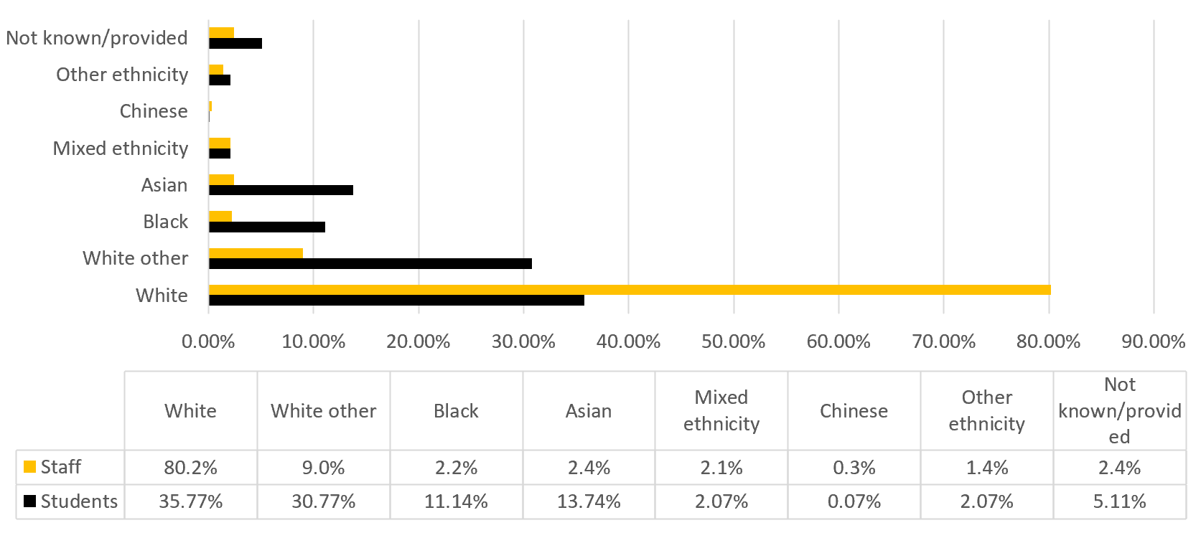

Figure 4. Staff and student ethnicity at 31 July 2021

By disability

Rates of declared disability for both staff and students are shown in Figure 5.

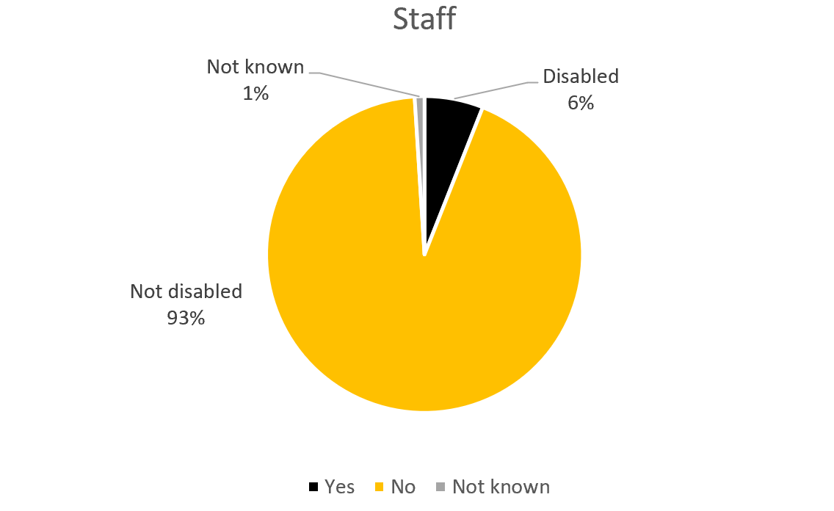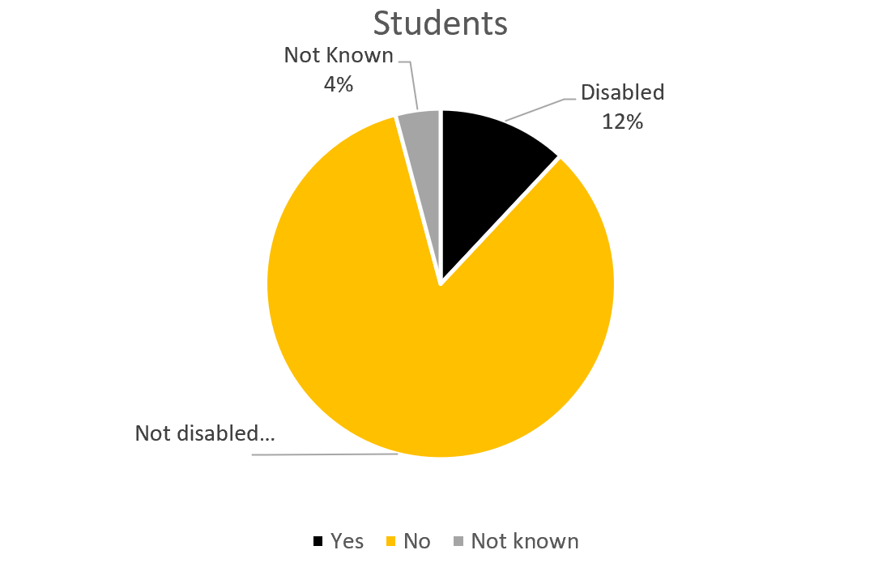

Figure 5. Staff and student declared disabilities 2020-21.

The percentage of disabled staff at 6.0% although considerably lower than national levels of working age adults (19%), is in line with the sector, where 5.5% of staff declare a disability. We will continue to work with our staff to ascertain the nature of their disability (hidden, visible or both) and to understand lived work experiences, and what we might do to address any inequality.

The proportion of students declaring a disability in 2020-21 has decreased from 22.8% in 2019-20 to 12%. We will work with our student services functions to look to analyse the data in respect of this to understand the reason behind the dop, when the general population disability level sits at 22%. Part of the institution’s commitment via the Access and Participation Plan (APP) is to reduce and/or eliminate gaps in continuation rates between part-time students known to have a disability compared to part-time students not known to have a disability, non-continuation of students with mental health conditions compared to students with no disability and to reduce / eliminate the degree attainment gap for full time students with disability compared to students with no disability, so student disability levels remain a pertinent issue.

By age

The majority of University of Suffolk students are in the 25-44 age range (as shown in Figure 6) which continues the upward trend of our university attracting more mature students than in a typical HEI.

Our staffing profile also aligns with this age profile – with the majority (50%) of our staff being aged between 25 and 44. Whilst this most likely represents the experience and qualification levels that may be required for many of our teaching/academic posts (which by their very nature will require a certain period of study and experience), the other age groups may require some review – particularly the 18-24 age group as at only 3% of the staffing profile this means that our roles may not be as accessible to younger candidates.

As we are an employer which does offer some ‘entry level’ roles it would be prudent to review and ensure our processes are not inadvertently reducing applications from within this age group. Our recruitment processes may also require a further ‘deep dive’ to ensure that our methods and places of advertising reach individuals across all age groups.

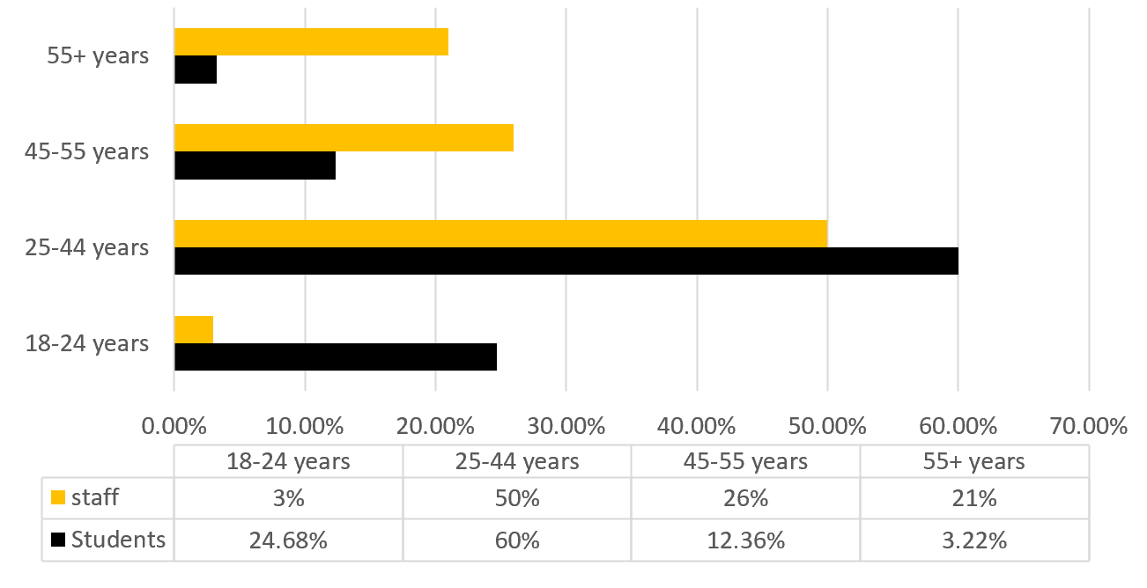

Figure 6. Staff and students by age range 2020-21

By sexual orientation

As can be seen in Figure 7, disclosure rates for sexual orientation could still be improved, particularly for staff. The pattern has remained similar to previous years. More staff report identifying as heterosexual/straight than last year, and we have seen a small increase in numbers of people who are declaring their status. We will continue to encourage and empower staff to feel comfortable to declare their sexuality status, which in turn will help us to better understand the needs of all of our staff, whatever their sexual orientation.

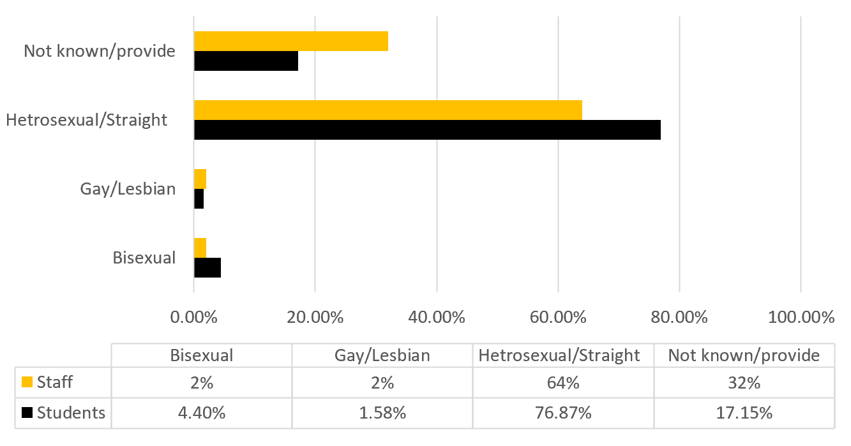

Figure 7. Staff and students by sexual orientation 2020-21.

By religion and belief

Our data shows that less students report having no religion – a change from 49.5% to 28.89% but there has been a small increase in students not providing information on their religion or beliefs (from 5.1% to 8.67%). Significantly more students report being Christian, Muslim or Sikh (43.27%, 14.81% and 20% respectively) when compared to last year (35.4%, 5.7% and 0.2% respectively).

Staffs’ religion and belief remain more consistent with data reported in 2019-20. The main reported categories for our staff are not provided (35%), no religion (35%) and Christian (26%). The University of Suffolk remains supportive of all individuals receiving support, whatever their faith, and so the continued integration of the multi-faith Chaplaincy remains an important part of our establishment.

Figure 8 shows the distribution of staff and students in terms of their reported religion and belief.

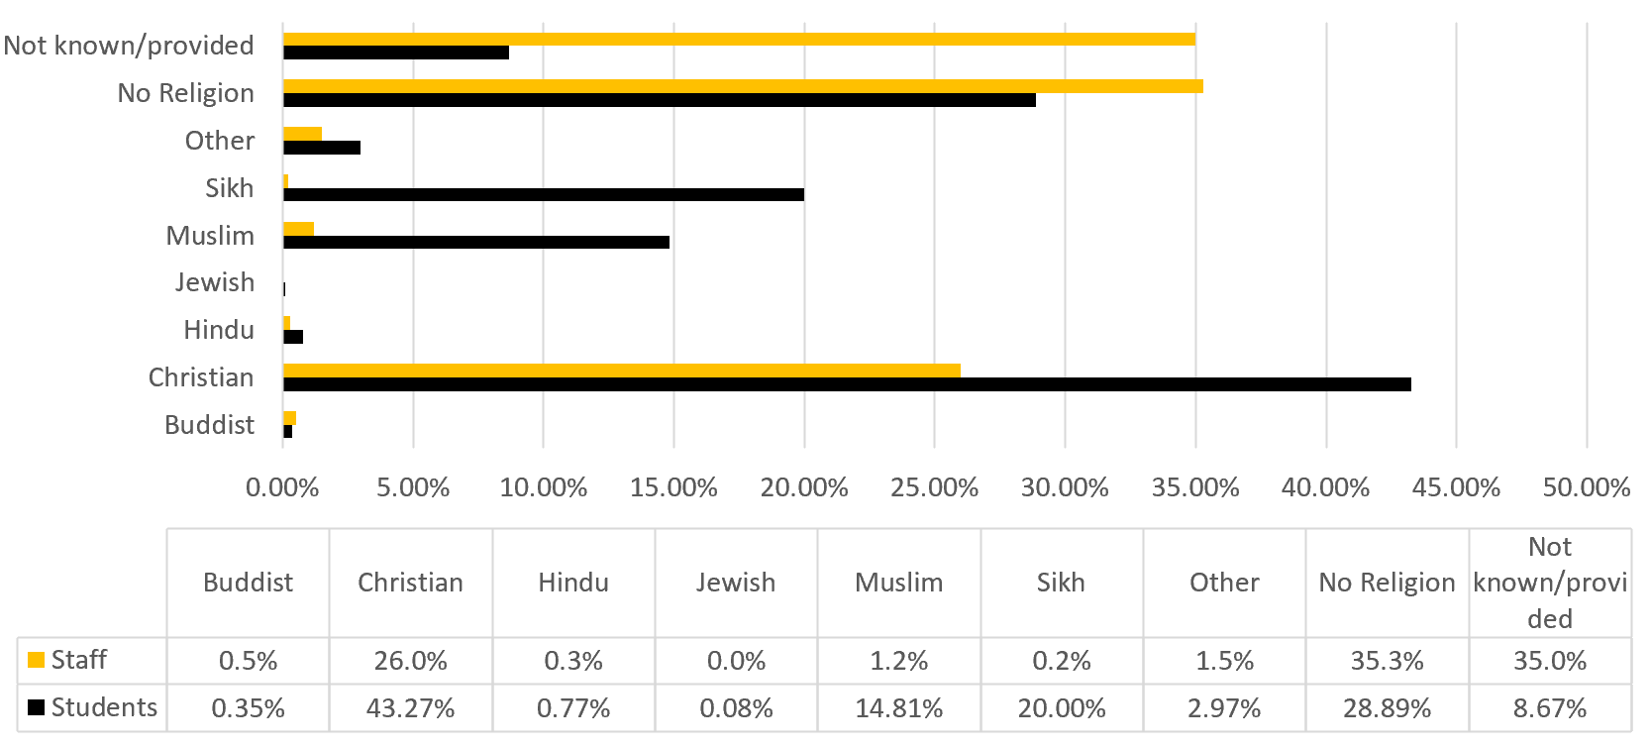
Figure 8. Staff and students by religion and belief 2020-21.

Activities and approach (2020-21)

Recruitment

We continue to be under-represented in our workforce by staff from black and minority ethnic (BAME) backgrounds and those with a disability and have seen applications decrease in both of these areas.

The number of applications from BAME applicants fell in 2020-21 to 16% (from 20%), however the number of appointments remained the same as last year at 7%. The number of applications from disabled applicants decreased from 13% to 9%, however the number of appointments increased from 7% to 9%.

We have endeavoured to encourage more BAME applicants by including a positive action statement on all our adverts and have shown our commitment to supporting the employment of those with disabilities through our participation in the Disability Confident scheme - the logo for which appears on our recruitment channels. We also state our intention to offer an interview to disabled applicants who meet the minimum essential criteria. We are working with the Job Centre Plus to pro-actively promote our roles to people with disabilities. We feel there remains further work to be done to encourage applications from these under-represented groups.

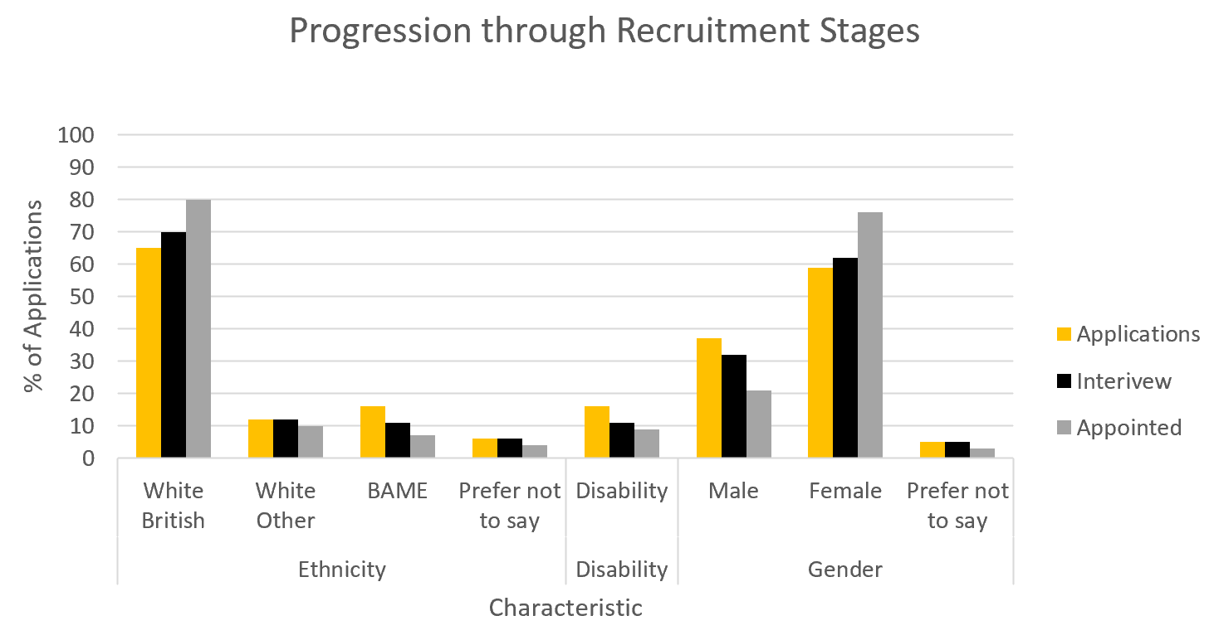

Figure 9: Progression through recruitment stages 2020-21

Academic progression

The information below reflects the outcomes from the academic progression round (all levels) held during 2020-21:

- There continue to be no applications from individuals who have declared a disability. However, on further review, although 25% of our disabled workforce are within the academic staff group, 55% of those have 3 years or less service. The majority of those with 3 years’ service or more are Senior Lecturers.
- There continues to be very few applications from part-time members of staff, only one received during this year’s round.
- Although the number of applications from BAME staff is small, it is proportionate to the number of members of staff within the academic staff group from a BAME background.

Professional Services progression

The annual grading review of Professional Services staff held during 2020/21 saw 3
submissions, 2 male and 1 female, all of whom were successful. None were from a BAME background or had a declared disability.

Student focus – Access & Participation

The work undertaken in recent years to write the institutional Access and Participation Plan (APP) 2020/21-2024/25 included extensive student consultation, with 90 students from under-represented groups taking part to offer their views. The Plan provides a detailed analysis of access, continuation, attainment and progression for BAME students, mature students, and those known to have a disability, mental health condition, as well as taking into consideration care leavers and intersections of disadvantage. Work has continued in this crucial area during 2020-21 with progress being made as detailed below. Figure 10 shows the targets and progression against them for equality protected groups as outlined in the 2019-20 EDI Annual Report, but included here again for clarity:

Access and Participation Plan | 2022/23 Target
Increase number of students who disclose a disability by 0.5% per year | 17.84%
Increase the number of students from BAME background by 0.25% per year | 14.23%
Increase mature student entrants for full-time UG degrees by 5% each year | 934

Figure 10. Access and Participation Plan targets.

Full information on the Access and Participation Plan can be found at: https://www.uos.ac.uk/sites/default/files/access-participation-plan-2020-2025.pdf

Continued activities to support student success and progression

Through our work on the Access and Participation plan we have set out to better understand the lived experience of being a student at the university, and barriers to either joining our community or to remaining within it. This has been done through our annual research and evaluation framework (2020-21) and further work is planned for 2021-22. Examples of this work include:

- Focus groups and interviews to hear rationale for choosing university and the University of Suffolk more specifically
- Experience of the process for accessing support and then engaging with it
- A training programme, in collaboration with AdvanceHE to explore learning and teaching through an EDI lens with specific focuses on participation experience and engagement, curriculum design and assessment and feedback
- Further analysis and exploration of the University approach to, application of and awareness of reasonable adjustments for students
- Analysis and understanding of the internal and external support provided to students with mental health conditions and the impact of this on retention and success.

From this work we are looking to develop a series of awareness and training activities as well as guidance and sharing of good practice.

Our initial findings make it clear to us that those students with disabilities do access more support and have benefitted more from the temporary assessment regulations which were adopted to mitigate impact of COVID. We appreciate that for many these challenges may not disappear and so we are looking at how these may or may not prove to be best practice beyond COVID.

Block and Blend
In direct response to the pandemic, the University has adopted a new approach to learning and teaching which is being piloted so that we can understand impact. The new approach sees our students move away from a model of 3 modules at once (if full time) over the course of a semester with end of semester assessment to a blocked approach which focusses learning on one module at a time, and spreads assessment throughout the academic year. Early qualitative data from students indicates that this approach to supports better time management and development of confidence. The blended approach, including the use of recorded lectures supports a more flexible approach to learning and the opportunity to recap during and beyond module assessment. This has proven popular with students and those with disability have noted their ability to be able to study from home if needed with resources and learning materials being more inclusive and accessible. Early quantitative data suggests an increase in achievement at assessment.

Analysis of this model continues through 2021-22.

Personal Academic Coach
Personal tutoring is used throughout HE to support and promote engagement and success. Across the sector there has been a shift to a more empowering coaching model, and this has now been developed and implemented. We believe that this model will support our students in the development of confidence as effective learners and provide focussed time to consider their own barriers to learning and opportunities for development. It also provides opportunity for course teams to signpost additional support and resources as needed and, on a case-by-case basis.

The move to this model and its impact on retention and success is being evaluated through 2021-22.

Equality, Diversity and Inclusion Governance

The University has put in place governance structures to ensure leadership, responsibility, accountability and oversight of Equality, Diversity and Inclusion, as shown in Figure 11.

Figure 11. Governance structures at the University of Suffolk relating to EDI

Equality, Diversity and Inclusion (EDI) Committee

The Equality, Diversity and Inclusion (EDI) Committee meets three times a year to:
- Monitor the key areas of the institution’s performance and priority areas agreed for the year in relation to EDI (currently: Access and Participation Plan; Athena Swan application, People and Liberating the Curriculum)
- Keep relevant policies and procedures (which influence or are influenced by EDI matters) under review
- Set, monitor, and report progress against equality objectives
The Committee has membership from across the institution’s community, including academic representatives, professional service managers, the recognised trades unions and the Students’ Union.
Members of the Senior Leadership Team are responsible for leading the implementation of the Equality and Diversity approach and action planning in relation to employee and student matters within their own Schools and Directorates/departments; and ensuring that all their staff know their responsibilities and receive support and training in carrying these out.
All members of the institution’s community have a responsibility to support the aims and objectives of the Equality and Diversity Policy, ensuring that their behaviour towards each other and to the wider external community is respectful, encouraging a positive and inclusive environment.

Policies and Procedures
As an institution we have a number of policies in place to support Equality, Diversity and Inclusion for our staff and our students. These policies have been reviewed in respect of Equality Impact Assessment (EIA). We are committed to embedding an authentically inclusive environment (through our policies, procedures and approach) for all who work and study at the University of Suffolk.

Equality Priorities 2021-22

Building upon the refresh of approach to EDI at the University in 2020-21 (including the re-establishment of the EDI Committee with clear focus topics), our priorities in EDI for 2021-22 are primarily to build upon and embed the work that has commenced in this respect.
Some of our priority areas span a number of years (Athena Swan, Access and Participation etc) and so to achieve an authentically embedded approach it is important that we afford the time they deserve to see transformational change and value adding impact. The priorities for the EDI Committee therefore remain as:
  - Access and Participation Plan
  - Athena Swan
  - People
  - Liberating the Curriculum

In addition, the People and OD team will be strengthening their knowledge of, and approach to EDI matters with the establishment of a new post – dedicated to EDI, during the 2021-22 academic year.
We continue to recognise the value that our supporting colleagues (for example, our staff networks) play in improving Equality, Diversity and Inclusion in its widest sense, for our staff and students. We recognise that to effect real change and improvement, Equality, Diversity and Inclusion is everyone’s responsibility and priority. We therefore remain committed to improving our understanding of EDI matters through our use of data, formal learning opportunities, shared experiences and by encouraging constructive challenge to any practices or approaches which do not align with our core values and behaviours.

Family Resources Survey 2019 to 2020
HESA 2019/20

